# Product Requirements Document (PRD)

## Airbnb Experiences Feature



### 1. Overview

**Overview**Airbnb Experiences is an innovative feature introduced by Airbnb that extends beyond traditional accommodations, allowing hosts to offer unique activities, workshops, and guided tours to travelers. This feature was designed to enhance the overall travel experience by connecting guests with local experts who curate immersive and culturally rich activities tailored to different interests.

Unlike conventional sightseeing tours, Airbnb Experiences enables travelers to participate in hands-on activities that provide an authentic glimpse into the local lifestyle, traditions, and expertise of the host. These experiences can range from food and wine tastings, adventure excursions, wellness retreats, and artistic workshops to exclusive behind-the-scenes access to local businesses, historic landmarks, or niche skills taught by professionals.

By offering these curated experiences, Airbnb bridges the gap between tourists and locals, fostering deeper engagement with the destination beyond just staying in a rental property. Travelers gain valuable insights into the culture, history, and traditions of a place through firsthand participation, making their journey more memorable and meaningful.

For hosts, Airbnb Experiences provides an additional revenue stream and an opportunity to share their knowledge, passion, and skills with a global audience. Whether it's a local chef teaching a cooking class, a photographer guiding a city tour, or an artist conducting a creative workshop, this feature empowers individuals to monetize their expertise in a flexible and scalable manner.

Airbnb ensures quality and authenticity by vetting and approving experiences before they are listed on the platform. Hosts must submit a detailed proposal outlining the activity, expected duration, pricing, and unique value proposition to ensure that it aligns with Airbnb’s standards for engagement, safety, and cultural relevance. Additionally, guests can review and rate experiences, helping future travelers make informed decisions based on previous participants' feedback.

Since its introduction, Airbnb Experiences has expanded globally, offering thousands of activities across multiple cities and regions. This feature has revolutionized the way people explore new destinations, moving beyond conventional tourist attractions and embracing interactive, meaningful experiences that foster connections between travelers and the communities they visit.



### 2. **Goals & Objectives**

### The primary goal of Airbnb Experiences is to enhance the platform’s value proposition by enabling hosts to offer engaging, high-quality experiences that go beyond traditional accommodations. By expanding its services, Airbnb aims to create a more immersive and interactive travel experience for guests while providing hosts with new opportunities to monetize their skills and expertise. The following objectives outline the key focus areas of this feature:

### **Enable Hosts to Create and Manage Experiences on the Platform** Airbnb Experiences empowers hosts by providing them with a structured platform where they can design, list, and manage unique activities. Hosts have the flexibility to create customized experiences based on their expertise, whether it’s cultural tours, hands-on workshops, adventure excursions, or wellness retreats. The platform offers intuitive tools to help hosts define experience details, pricing, scheduling, and guest capacity while ensuring smooth communication with participants. By streamlining the hosting process, Airbnb encourages individuals with diverse backgrounds—artists, chefs, athletes, historians, and entrepreneurs—to share their passions with a global audience.

### **Provide Guests with Curated, High-Quality Experiences Tailored to Their Interests** Airbnb Experiences aims to cater to a wide range of traveler preferences by offering meticulously curated activities across various categories such as food and drink, arts and culture, sports, nature, and wellness. The platform ensures that each experience provides authentic, enriching, and enjoyable interactions with local experts. By leveraging personalized recommendations, user preferences, and traveler reviews, Airbnb helps guests discover experiences that align with their interests, ensuring a memorable and engaging journey. Whether it’s learning to cook a regional dish with a local chef, exploring hidden gems with a professional photographer, or participating in a traditional craft-making session, guests can access a diverse array of meaningful activities.

### **Increase User Engagement and Revenue for Airbnb by Expanding Beyond Accommodations** Diversifying its offerings beyond home rentals allows Airbnb to strengthen its brand presence in the travel industry and attract a broader audience. By incorporating experiences into its ecosystem, Airbnb enhances user engagement, encouraging travelers to spend more time on the platform and explore various services beyond lodging. This expansion not only provides an additional revenue stream for hosts but also contributes to Airbnb’s overall financial growth by generating commission-based earnings from booked experiences. Moreover, integrating experiences with accommodations allows travelers to plan their entire trip within a single platform, fostering convenience and loyalty among users.

### **Ensure Safety and Quality Through a Streamlined Review and Verification Process** Maintaining high standards of safety, authenticity, and quality is a fundamental objective of Airbnb Experiences. To achieve this, the platform implements a comprehensive verification process that evaluates the credibility, feasibility, and uniqueness of each experience before it is made available to guests. Hosts must submit detailed proposals, outlining their planned activities, safety measures, and expected guest experience, which undergo a thorough review by Airbnb’s team. Additionally, guest reviews and ratings play a crucial role in ensuring transparency and accountability, allowing future participants to make informed decisions. By enforcing strict quality control mechanisms and safety guidelines, Airbnb fosters trust between hosts and guests, ensuring a secure and enjoyable experience for all.

### By aligning with these objectives, Airbnb Experiences continues to redefine the way travelers explore destinations, fostering deeper connections between people, places, and cultures through meaningful, hands-on activities.

### 







### 3. Key Features

### **Key Features for Hosts**

* Airbnb Experiences provides hosts with a robust set of tools and features designed to help them create, manage, and optimize their unique offerings. These features ensure that hosts have full control over their experiences while maintaining a seamless and professional interaction with guests.

#### **1. Experience Listing: Ability to Create, Edit, and Manage Experience Listings**

* Airbnb enables hosts to design and customize their experience listings with a user-friendly interface that allows for seamless creation and management. Hosts can provide detailed descriptions, upload high-quality images, and highlight key aspects of their activities to attract potential guests. The listing process includes fields for experience duration, difficulty level, target audience, and any special requirements or materials needed. Additionally, hosts have the flexibility to edit and update their listings at any time to refine their offerings, adjust descriptions, or modify activity details based on feedback and demand trends.

#### **2. Availability Management: Set Schedules, Blackout Dates, and Capacity Limits**

* To ensure smooth scheduling and organization, Airbnb provides hosts with a comprehensive availability management system. Hosts can set specific dates and times for their experiences, allowing them to plan their schedules in advance. The platform also includes options to establish blackout dates, which prevent bookings on unavailable days, such as holidays or personal commitments. Additionally, capacity limits can be set to control the number of participants per session, ensuring a high-quality and manageable experience for guests. This feature allows hosts to balance their workload efficiently while maintaining an optimal guest experience.

#### **3. Pricing & Payment: Set Price Per Person or Group, Manage Discounts, and Track Earnings**

* Airbnb offers hosts complete flexibility in setting pricing structures based on their experience type, location, and market demand. Hosts can choose to charge per person or offer group pricing, making it easier to accommodate different booking preferences. The platform also allows hosts to apply discounts or promotional pricing to attract more guests during off-peak seasons or special events. To help hosts track their financial performance, Airbnb provides an earnings dashboard that displays revenue breakdowns, completed transactions, and payout schedules. This transparency ensures that hosts have clear visibility into their income and can make informed decisions to optimize their pricing strategy.

#### **4. Guest Interaction: Messaging System to Communicate with Participants**

* Effective communication is key to delivering a smooth and enjoyable experience. Airbnb’s built-in messaging system allows hosts to engage with guests before, during, and after the booking process. Hosts can answer questions, provide additional details about the experience, share meeting locations, and clarify any special requirements. The messaging feature enhances guest confidence by allowing direct interaction with the host, ensuring that expectations are aligned, and fostering a sense of trust and reliability.

#### **5. Review & Ratings: Collect Feedback from Guests to Improve Credibility**

* To maintain high-quality standards and build a strong reputation, Airbnb enables hosts to receive reviews and ratings from guests who have participated in their experiences. After each session, guests are encouraged to leave feedback based on their satisfaction, the host’s expertise, and the overall experience quality. Positive reviews help hosts attract more bookings, while constructive feedback provides valuable insights for improving future experiences. Hosts can respond to reviews, engage with their audience, and refine their offerings based on real user input. This feature plays a crucial role in enhancing credibility and ensuring continuous improvement in the quality of experiences offered.
* By integrating these essential features, Airbnb Experiences empowers hosts to create well-structured, engaging, and profitable activities that cater to travelers seeking unique and meaningful adventures.

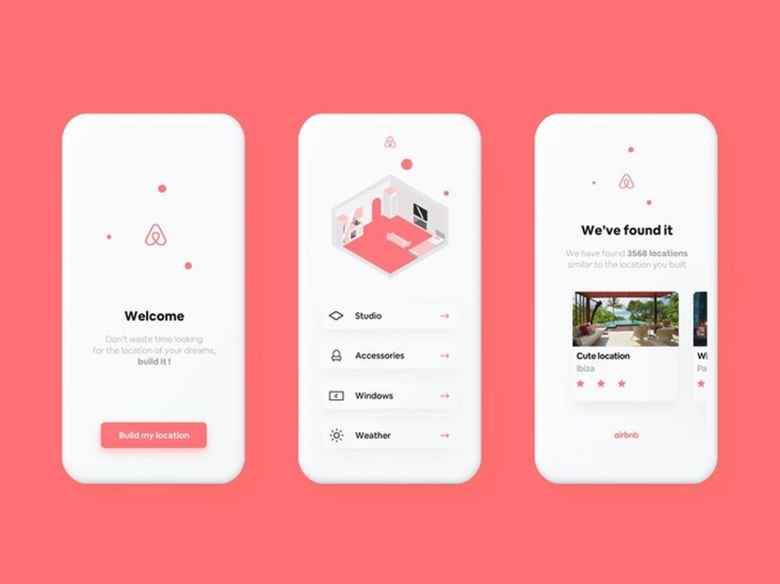

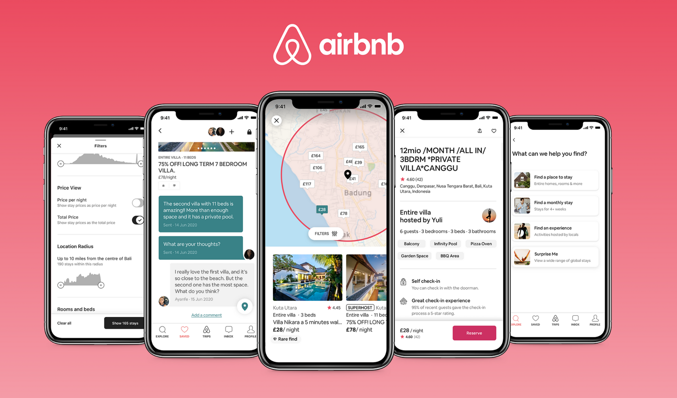

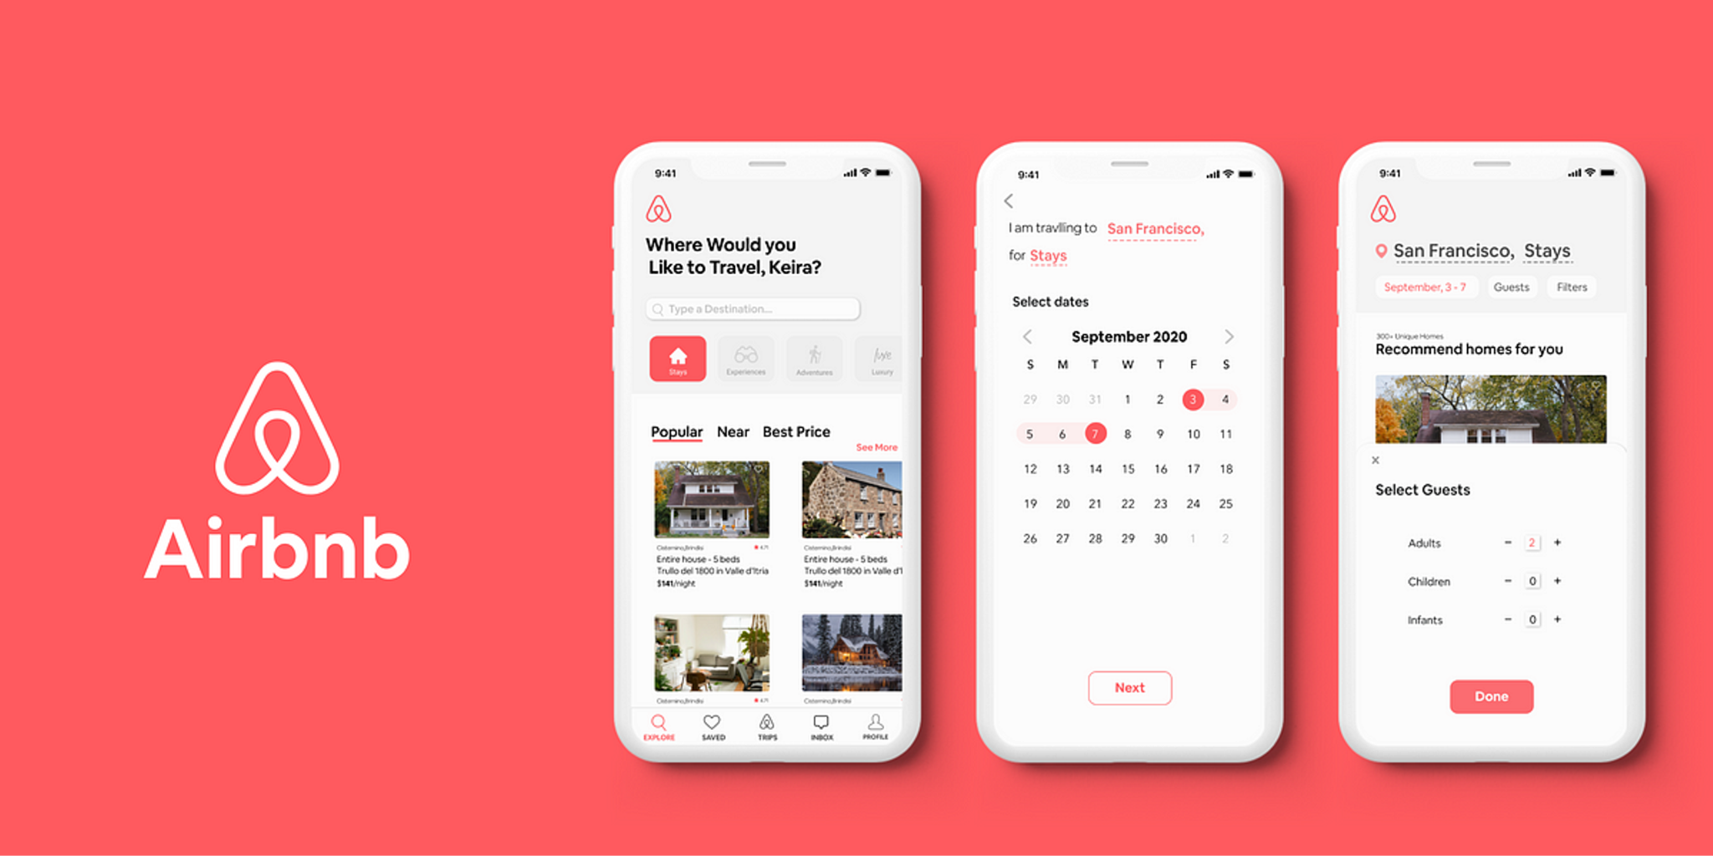

### **Key Features for Guests**

Airbnb Experiences is designed to provide travelers with a seamless and engaging way to discover, book, and enjoy unique activities hosted by local experts. To enhance the user experience, Airbnb offers a range of features that help guests find the perfect experience, complete secure transactions, and make informed decisions based on reviews and personalized recommendations.

#### **1. Experience Discovery: Search, Filter, and Browse Experiences Based on Location, Category, and Ratings**

Guests have access to a powerful search and discovery system that allows them to explore a wide variety of experiences based on their preferences. The platform provides multiple ways to refine searches, including:

* **Location-Based Search**: Guests can explore experiences available in specific cities, neighborhoods, or travel destinations.
* **Category-Based Filters**: Experiences are categorized into different types such as food and drink, arts and culture, wellness, adventure, history, and nature, enabling users to find activities that align with their interests.
* **Ratings and Reviews**: Guests can filter experiences based on previous participant reviews and overall ratings, ensuring they select high-quality and well-reviewed activities.
* **Price Range and Availability**: Users can set budget preferences and check for availability on their desired travel dates, making it easier to find experiences that fit their schedule and financial plan.  
  This intuitive discovery system ensures that guests can easily navigate the platform and find experiences tailored to their personal tastes and travel plans.

#### **2. Booking & Payment: Secure Booking and Payment Options**

Airbnb Experiences offers a streamlined and secure booking process that allows guests to reserve their spots with confidence. The platform provides:

* **Instant Booking or Host Approval**: Some experiences can be booked instantly, while others may require host confirmation before finalizing the reservation.
* **Multiple Payment Methods**: Guests can pay using credit/debit cards, PayPal, Apple Pay, Google Pay, or Airbnb credits, ensuring flexibility and convenience.
* **Transparent Pricing**: All costs, including taxes and potential additional fees, are clearly displayed before checkout, eliminating surprises.
* **Flexible Cancellation Policies**: Hosts can set cancellation policies ranging from flexible to strict, allowing guests to make informed decisions before booking.
* **Booking Confirmation and Itinerary Details**: Once a booking is completed, guests receive a confirmation email with all relevant details, including meeting locations, experience duration, and host contact information.  
  With these features, Airbnb ensures a seamless and worry-free booking process that enhances user trust and convenience.

#### **3. Reviews & Recommendations: View Reviews from Other Guests and Get AI-Driven Recommendations**

Airbnb prioritizes transparency and personalization by offering a robust review and recommendation system that helps guests make informed choices.

* **Guest Reviews & Ratings**: After attending an experience, guests can leave detailed feedback and star ratings based on factors like host knowledge, experience quality, and overall enjoyment. These reviews are visible to future guests, helping them choose activities with confidence.
* **AI-Driven Personalized Recommendations**: Airbnb leverages artificial intelligence to provide personalized recommendations based on a guest’s browsing history, past bookings, and user preferences. The platform suggests relevant experiences that align with the traveler’s interests, ensuring a more tailored and engaging discovery process.
* **Trending and Popular Experiences**: The platform highlights top-rated and trending experiences in different destinations, helping guests discover unique activities that have received positive feedback from previous participants.
* **Experience Comparisons**: Guests can compare multiple experiences side by side, evaluating factors such as pricing, duration, reviews, and host expertise before making a decision.

By incorporating these key features, Airbnb Experiences provides guests with a seamless, user-friendly, and trustworthy platform for discovering and booking unique, high-quality activities during their travels.



### 4. User Flow

### **User Flow for Hosts**

Airbnb provides a structured and user-friendly process for hosts to create, manage, and optimize their experiences on the platform. The step-by-step flow ensures that hosts can efficiently list their activities while maintaining quality standards and compliance with Airbnb’s guidelines.

#### **1. Sign Up or Log In**

To start hosting an experience, users must first have an Airbnb account. New hosts can sign up by providing basic details such as their name, email address, and phone number, or by linking an existing Google, Apple, or Facebook account. Existing Airbnb hosts or users can simply log in with their credentials to access the hosting dashboard.

#### **2. Navigate to the "Create an Experience" Section**

Once logged in, users can access the Airbnb Experiences portal via the hosting dashboard. Here, they will find the **"Create an Experience"** option, which guides them through the process of setting up their experience listing. Airbnb provides an intuitive step-by-step interface to help hosts structure their experiences effectively.

#### **3. Enter Experience Details**

Hosts must provide comprehensive information about their experience, ensuring clarity, engagement, and alignment with Airbnb’s quality standards. The required details include:

* **Title**: A catchy and descriptive name that highlights the essence of the experience.
* **Description**: A detailed overview outlining what guests can expect, key highlights, and any unique aspects.
* **Photos & Videos**: High-quality images or videos showcasing the experience, location, and any special features.
* **Pricing**: Options for per-person or group pricing, along with any discounts or special rates.
* **Availability**: Scheduling options, including available dates, time slots, blackout dates, and maximum capacity limits.
* **Meeting Point & Location Details**: Clear instructions on where guests should arrive and how to find the host.
* **Safety Requirements**: Any necessary safety precautions, equipment, or experience prerequisites (e.g., fitness level for adventure experiences).
* **Additional Notes**: Any materials guests need to bring, dress codes, or other relevant details.

Hosts are encouraged to make their listings as detailed and engaging as possible to attract more bookings and enhance guest satisfaction.

#### **4. Submit for Airbnb Verification**

Once all details are provided, hosts must submit their experience for Airbnb’s review and approval process. Airbnb evaluates each listing based on the following criteria:

* **Authenticity**: Ensuring the experience offers unique, local, and immersive value.
* **Engagement**: Assessing whether the activity allows for meaningful guest participation.
* **Safety & Compliance**: Verifying that the experience meets Airbnb’s safety guidelines and policies.

This verification process helps maintain quality and ensures that only high-value experiences are listed on the platform.

#### **5. Upon Approval, Experience is Live for Booking**

Once Airbnb approves the experience, it becomes publicly available on the platform for guests to browse and book. The listing will appear in relevant search results based on category, location, and keywords. Hosts receive notifications when their experience goes live and can begin promoting their activity to attract bookings.

#### **6. Manage Bookings and Guest Interactions via Dashboard**

After an experience is live, hosts can monitor and manage all aspects of their bookings through Airbnb’s hosting dashboard. This includes:

* **Booking Management**: Accepting or declining requests, tracking upcoming reservations, and modifying schedules as needed.
* **Guest Communication**: Using Airbnb’s built-in messaging system to answer guest inquiries, provide additional details, and ensure smooth coordination.
* **Earnings & Payout Tracking**: Viewing revenue breakdowns, tracking earnings, and managing payouts.
* **Review & Feedback Management**: Reading guest reviews, responding to feedback, and making adjustments to enhance the experience based on user suggestions.

By following this structured user flow, hosts can efficiently create and manage successful experiences while maximizing guest satisfaction and earning potential.

### **User Flow for Guests**

Airbnb Experiences offers a seamless and user-friendly journey for guests looking to discover and participate in unique activities hosted by local experts. The platform ensures an intuitive booking process, from browsing experiences to attending the event and sharing feedback.

#### **1. Sign Up or Log In**

Before booking an experience, guests must have an Airbnb account. They can either:

* **Sign Up**: New users can create an account by entering their email, phone number, and personal details or by signing up via Google, Apple, or Facebook.
* **Log In**: Existing Airbnb users can simply log in with their credentials to access their personalized dashboard, saved experiences, and previous bookings.

#### **2. Browse Experiences by Category, Location, or Recommendations**

Guests can explore a vast collection of experiences through Airbnb’s powerful search and filtering system. They can:

* **Search by Destination**: Enter a city or region to find available experiences in that location.
* **Filter by Category**: Narrow down results by selecting specific categories such as Food & Drink, Arts & Culture, Adventure, Sports, Nature, and Wellness.
* **Sort by Ratings and Popularity**: View top-rated, trending, or highly recommended experiences based on previous guest reviews.
* **Use Personalized Recommendations**: Airbnb’s AI-driven system suggests experiences based on the guest’s past bookings, preferences, and browsing history.

This step allows travelers to efficiently find activities that align with their interests and travel itinerary.

#### **3. Select an Experience, View Details, and Check Availability**

Once a guest finds an appealing experience, they can click on the listing to view:

* **Detailed Description**: An overview of the activity, including what to expect and key highlights.
* **Host Information**: Background on the host, their expertise, and guest reviews.
* **Experience Duration and Schedule**: Exact time slots, dates, and duration of the experience.
* **Pricing & Inclusions**: Breakdown of the cost, whether it’s per person or group, and what’s included in the experience (e.g., meals, equipment, transportation).
* **Location & Meeting Point**: Instructions on where the experience will take place and how to get there.
* **Guest Requirements**: Any prerequisites such as age limits, physical fitness level, or necessary materials.

Guests can check the availability of the experience based on their preferred travel dates and select a time slot that works best for them.

#### **4. Book Experience and Complete Payment**

Once a guest decides to book an experience, they proceed to the secure payment process. The booking process includes:

* **Instant Booking or Host Approval**: Some experiences allow instant confirmation, while others require the host to approve the booking.
* **Payment Methods**: Guests can pay using various options, including credit/debit cards, PayPal, Apple Pay, Google Pay, or Airbnb credits.
* **Pricing Transparency**: All fees, including taxes and any additional costs, are displayed upfront before payment.
* **Flexible Cancellation Policy**: Guests can review the host’s cancellation terms before confirming their booking.

After completing the payment, guests receive an on-screen confirmation along with a confirmation email containing all relevant details.

#### **5. Receive Confirmation and Communicate with Host if Needed**

Upon successful booking, guests gain access to their trip itinerary and have the option to communicate with the host directly through Airbnb’s messaging system. This allows them to:

* **Confirm Any Special Requests**: Discuss dietary restrictions, accessibility concerns, or customizations.
* **Ask for Additional Details**: Clarify meeting locations, what to bring, or specific activity logistics.
* **Receive Important Updates**: Hosts can share last-minute changes, weather advisories, or additional instructions.

This feature ensures that both guests and hosts are well-prepared before the experience takes place.

#### **6. Attend Experience and Leave a Review Afterward**

On the scheduled date, guests attend the experience and engage in the activity as planned. After the experience concludes, they are encouraged to:

* **Leave a Rating & Review**: Share feedback about the host, activity quality, and overall experience.
* **Provide Constructive Comments**: Suggest improvements or highlight aspects they particularly enjoyed.
* **Help Future Guests**: Reviews contribute to the credibility of experiences and assist other travelers in making informed decisions.

Guest feedback plays a crucial role in maintaining Airbnb’s quality standards and rewarding hosts who provide exceptional experiences.

### 5. Safety & Verification

Airbnb prioritizes the safety of both hosts and guests by implementing a comprehensive verification and monitoring system. This ensures that all experiences meet high-quality standards while maintaining a secure and trustworthy environment for users. The platform follows strict guidelines for host background checks, experience approvals, and guest protection mechanisms to uphold the integrity of its offerings.

#### **1. Host Background Checks & Safety Guidelines**

To ensure guest safety and experience quality, Airbnb requires all hosts offering experiences to undergo a thorough verification process, which includes:

* **Identity Verification**: Hosts must provide valid government-issued identification, such as a passport or driver’s license, to confirm their authenticity.
* **Background Checks (Where Applicable)**: In select regions, Airbnb conducts background checks on hosts to screen for criminal records or any history of fraudulent activity.
* **Safety Guidelines Compliance**: Hosts must adhere to Airbnb’s safety policies, including:
  + Providing accurate information about potential risks involved in the experience.
  + Ensuring necessary safety measures (e.g., equipment, emergency plans) are in place for activities such as adventure sports or outdoor excursions.
  + Communicating any health, liability, or insurance requirements to guests before booking.

By enforcing these measures, Airbnb aims to create a safe and welcoming environment for travelers engaging in experiences worldwide.

#### **2. Airbnb Manual Review & Approval of New Experience Listings**

To maintain quality control, Airbnb does not automatically approve all new experience listings. Instead, the platform has a dedicated review team that:

* **Manually Evaluates Listings**: Every new experience submitted by a host undergoes a thorough review process to ensure compliance with Airbnb’s guidelines.
* **Assesses Authenticity & Engagement**: Airbnb verifies whether the experience provides a unique, engaging, and interactive activity rather than a generic tourist service.
* **Reviews Safety & Compliance**: The approval process includes verifying that experiences comply with local laws, safety regulations, and Airbnb’s policies.
* **Provides Feedback or Requests Modifications**: If an experience does not meet standards, Airbnb may request the host to make adjustments before approval.

This manual review system ensures that only high-quality, well-vetted experiences are listed on the platform.

#### **3. Guest Safety, Dispute Resolution & Refund Mechanisms**

To protect guests and ensure they have a positive experience, Airbnb provides multiple safeguards, including:

* **Issue Reporting**: Guests can report safety concerns, misleading descriptions, or unsatisfactory experiences directly through the Airbnb platform.
* **Dispute Resolution**: If an issue arises, Airbnb’s support team facilitates communication between the guest and host to resolve conflicts fairly.
* **Refund Policy**: If an experience is canceled by the host or does not match the description, guests may be eligible for a full or partial refund based on Airbnb’s refund policy.
* **Emergency Assistance**: Airbnb provides in-app emergency contact support in certain regions, allowing guests to quickly access local emergency services if needed.

These safety and verification measures help maintain trust within the Airbnb community, ensuring that guests can confidently book and participate in experiences while knowing their well-being is a priority.

### 6. Revenue Model

Airbnb Experiences operates on a commission-based revenue model, generating income by charging hosts a percentage of each successful booking. Additionally, Airbnb offers optional promotional tools to help hosts enhance the visibility of their experiences, creating multiple revenue streams for the platform.

#### **1. Commission on Experience Bookings (15-20%)**

Airbnb charges hosts a **service fee ranging from 15% to 20%** on every experience booking. This commission is deducted from the host’s earnings before payout and covers:

* **Platform Maintenance & Security**: Ensuring a seamless booking experience, secure transactions, and fraud prevention.
* **Marketing & Guest Acquisition**: Promoting experiences to a global audience through targeted marketing campaigns, search engine optimization, and personalized recommendations.
* **Customer Support & Dispute Resolution**: Providing 24/7 assistance to both hosts and guests, including issue resolution and refund management.

The commission percentage may vary based on factors such as experience category, host location, and promotional offers by Airbnb.

#### **2. Optional Premium Placements for Hosts (Paid Promotions)**

To increase visibility and attract more bookings, Airbnb offers **optional paid promotional tools** for hosts who want to enhance their reach. These include:

* **Sponsored Listings**: Hosts can pay for their experiences to appear at the top of search results in relevant categories or locations.
* **Featured Experiences**: Airbnb curates and promotes select experiences on homepage banners, email newsletters, and social media for an additional fee.
* **Boosted Search Ranking**: Hosts can invest in premium placements that increase their chances of being discovered by travelers searching for experiences in their area.

By leveraging these monetization strategies, Airbnb maximizes revenue while providing hosts with valuable tools to grow their business.

### 7. Success Metrics

To measure the effectiveness and growth of Airbnb Experiences, several key performance indicators (KPIs) are tracked. These metrics provide insights into platform performance, user engagement, and overall revenue generation.

#### **1. Number of Experiences Listed and Booked**

* **Total Active Listings**: The number of experiences available on the platform, reflecting the expansion of Airbnb’s offerings.
* **Booking Volume**: The total number of experiences booked within a given period, indicating demand and guest interest.
* **Conversion Rate**: The percentage of visitors who browse experiences and proceed to complete a booking.
* **Geographical Growth**: Expansion of experiences across different cities and regions, demonstrating market penetration.

#### **2. Guest Satisfaction Ratings and Reviews**

* **Average Experience Rating**: The overall guest rating (out of 5 stars) based on feedback.
* **Review Sentiment Analysis**: Assessing positive vs. negative guest reviews to identify trends and areas for improvement.
* **Recommendation Rate**: The percentage of guests who would recommend an experience to others, showcasing customer satisfaction and loyalty.
* **Cancellation & Refund Rate**: Tracking the frequency of cancellations and refund requests to identify service or quality issues.

#### **3. Revenue Growth from Experience Bookings**

* **Total Revenue from Experiences**: The gross income generated through bookings, including Airbnb’s commission.
* **Year-over-Year (YoY) Growth**: Comparing revenue across different time periods to analyze trends.
* **Host Earnings**: The total payout to hosts, reflecting financial success and host satisfaction.
* **Impact of Paid Promotions**: Revenue generated from premium placements and sponsored listings.

#### **4. Host Retention and Engagement**

* **Host Retention Rate**: The percentage of hosts who continue listing experiences over time.
* **Host Activity Level**: Frequency of host interactions, such as responding to guest messages, updating listings, and managing availability.
* **Repeat Hosts**: The number of hosts who create multiple experiences, showcasing platform success in fostering long-term engagement.
* **Experience Iteration & Improvement**: Percentage of hosts who modify or enhance their experiences based on guest feedback, demonstrating platform adaptability.

### 8. Technical Requirements

To ensure seamless functionality, scalability, and an optimal user experience, Airbnb Experiences must adhere to a robust set of technical requirements. These requirements ensure smooth integration with Airbnb’s existing ecosystem, a high-quality user interface across platforms, intelligent recommendations, and a scalable backend to accommodate global demand.

#### **1. Integration with Airbnb’s Existing Payment and Booking System**

* **Seamless Payment Processing**: The experience booking system must be fully integrated with Airbnb’s existing payment gateway, supporting multiple payment methods, including credit/debit cards, PayPal, Apple Pay, Google Pay, and Airbnb credits.
* **Secure Transactions**: End-to-end encryption and compliance with financial regulations (e.g., PCI DSS) to protect user payment data.
* **Dynamic Pricing & Discounts**: Hosts should be able to configure dynamic pricing, set per-person or group rates, and apply discounts based on demand or promotions.
* **Automated Payouts for Hosts**: Airbnb’s system should handle commission deductions and release payments to hosts based on completed bookings.
* **Refund & Cancellation Management**: Automated handling of refund requests and cancellations according to Airbnb’s policies.

#### **2. Mobile and Web UI/UX Optimization**

* **Cross-Platform Compatibility**: Airbnb Experiences must offer a seamless and responsive design for both web and mobile applications (iOS and Android).
* **Intuitive User Interface**: A user-friendly experience with clear navigation, streamlined booking processes, and engaging visual elements.
* **Accessibility Compliance**: Adherence to WCAG (Web Content Accessibility Guidelines) to ensure usability for individuals with disabilities.
* **Fast Load Times & Performance Optimization**: Efficient caching strategies, optimized images, and content delivery networks (CDN) to minimize latency and enhance user experience.
* **Localized Experience**: Support for multiple languages, currencies, and region-specific recommendations.

#### **3. AI-Powered Recommendation System for Personalized Suggestions**

* **Machine Learning Algorithms**: AI-driven models analyze user behavior, past bookings, preferences, and reviews to provide personalized experience recommendations.
* **Contextual Filtering**: Suggestions based on factors such as location, seasonality, price range, and user interests.
* **Real-Time Adaptability**: The recommendation engine should continuously learn from user interactions and dynamically adjust recommendations to enhance engagement.
* **Natural Language Processing (NLP) for Search**: AI-powered search enhancements, allowing guests to find experiences using conversational queries.

#### **4. Scalable Backend to Support Global Operations**

* **Cloud-Based Infrastructure**: A highly scalable cloud environment (e.g., AWS, Google Cloud, or Azure) to handle millions of transactions and users worldwide.
* **Microservices Architecture**: Modular, loosely coupled backend services to support booking, payments, reviews, notifications, and messaging independently.
* **High Availability & Fault Tolerance**: Load balancing, failover mechanisms, and distributed database systems to ensure minimal downtime and uninterrupted service.
* **Real-Time Notifications & Updates**: WebSockets or push notifications to provide instant updates on bookings, messages, and status changes.
* **Data Security & Compliance**: Implementation of strong security protocols, GDPR compliance, and user data protection mechanisms to safeguard sensitive information.

### 9. Timeline

* Phase 1 (3 months): Research, UX/UI design, backend development.
* Phase 2 (3 months): Beta testing in select cities, feedback collection.
* Phase 3 (6 months): Global rollout and feature enhancements.

### 10. Risks & Mitigation

To maintain high standards, ensure guest safety, and support global expansion, Airbnb Experiences must implement strict host quality control, guest safety measures, and a scalable infrastructure. These elements are crucial for delivering a reliable and seamless user experience while fostering trust within the community.

#### **1. Host Quality Control: Strict Approval Guidelines and Ongoing Monitoring**

* **Comprehensive Onboarding & Vetting**:
  + Hosts must undergo a **rigorous approval process** to ensure their experience meets Airbnb’s quality and safety standards.
  + Each new experience listing is manually reviewed for authenticity, engagement, and compliance with platform guidelines.
* **Ongoing Quality Monitoring**:
  + Airbnb continuously evaluates hosts based on guest reviews, ratings, and feedback.
  + Listings with consistently poor ratings or guest complaints may be flagged for additional review or removal.
  + Airbnb may conduct periodic audits, including mystery guest evaluations, to maintain service quality.
* **Host Performance Metrics**:
  + Response time, cancellation rates, and guest satisfaction scores are tracked to assess host reliability.
  + Hosts with exceptional reviews may receive **"Superhost"** status or other promotional incentives.

By enforcing strict quality control, Airbnb ensures that guests have access to **only the best, most reliable experiences** on the platform.

#### **2. Guest Safety: Background Checks and Emergency Support**

* **Background Checks & Identity Verification**:
  + In select regions, Airbnb conducts background checks on both hosts and guests to **screen for criminal history** or fraudulent activity.
  + Guests and hosts must verify their identity through government-issued IDs and facial recognition technology to enhance security.
* **Emergency Support & Safety Resources**:
  + Airbnb provides **in-app emergency assistance**, enabling guests to quickly access **local emergency services** when needed.
  + Hosts must provide **detailed safety guidelines** for high-risk experiences (e.g., adventure sports, wildlife excursions).
  + Clear instructions on emergency procedures, medical support, and liability waivers are required for applicable experiences.
* **Issue Reporting & Dispute Resolution**:
  + Guests can **report safety concerns** directly through the Airbnb app.
  + Airbnb’s **Trust & Safety team** reviews reports and takes action, including issuing refunds or removing unsafe listings.

By prioritizing guest safety, Airbnb builds trust and encourages users to confidently explore new experiences.

#### **3. Scalability Issues: Cloud-Based Infrastructure for Performance Optimization**

* **Global Cloud Hosting & Auto-Scaling**:
  + Airbnb leverages a **cloud-based infrastructure** (AWS, Google Cloud, or Azure) to handle global traffic efficiently.
  + **Auto-scaling mechanisms** dynamically adjust resources to accommodate peak demand, preventing system slowdowns.
* **Optimized Data Storage & Processing**:
  + **Distributed databases** (e.g., PostgreSQL, MongoDB, or Cassandra) ensure rapid data access and reliability.
  + **Content Delivery Networks (CDN)** accelerate load times for users worldwide, reducing latency.
* **Fault Tolerance & Disaster Recovery**:
  + **Load balancing** ensures smooth operation by distributing traffic across multiple servers.
  + **Automated failover systems** keep the platform running even if a server or data center experiences downtime.
  + **Regular backups** protect user data and prevent service interruptions.

A robust and scalable infrastructure allows Airbnb to handle **millions of bookings**, ensuring a smooth and uninterrupted experience for both guests and hosts.

By implementing these quality control, safety, and scalability measures, Airbnb can continue to provide **a secure, high-quality, and globally scalable platform** for travelers and hosts alike.

### 11. Conclusion

The **Airbnb Experiences** feature is designed to offer travelers a seamless, engaging, and immersive way to explore unique activities while enabling hosts to monetize their skills, knowledge, and passions. By connecting guests with local experts, Airbnb fosters authentic cultural exchanges and enhances travel beyond just accommodations.

Through this initiative, Airbnb aims to:

* **Increase User Engagement**: Providing guests with curated, high-quality experiences tailored to their interests encourages longer platform usage and repeat bookings.
* **Diversify Revenue Streams**: Expanding beyond traditional lodging allows Airbnb to generate additional revenue through experience bookings and premium host promotions.
* **Enhance the Overall Travel Experience**: By offering one-of-a-kind activities, workshops, and guided tours, Airbnb transforms how travelers engage with destinations, making trips more memorable and meaningful.

By continuously refining host quality control, prioritizing guest safety, and maintaining a scalable technical infrastructure, Airbnb Experiences positions itself as a **trusted global marketplace for unique, high-quality activities**, enriching both guests' and hosts' experiences worldwide.